**CSS - Customer Portal Framework for MSC**

**1. Dashboard**

* **Key Metrics Overview**:
  + Departure City
    - Shipment
    - Weight
    - Volume
    - Order
  + Destination City
    - Shipment
    - Weight
    - Volume
    - Order
  + Transport Mode
    - Truck
    - Sea freight
      * LCL
      * FCL
    - Air freight
    - Courier Express
  + Total Weight
  + Total Volume
  + Orders
  + Shipments

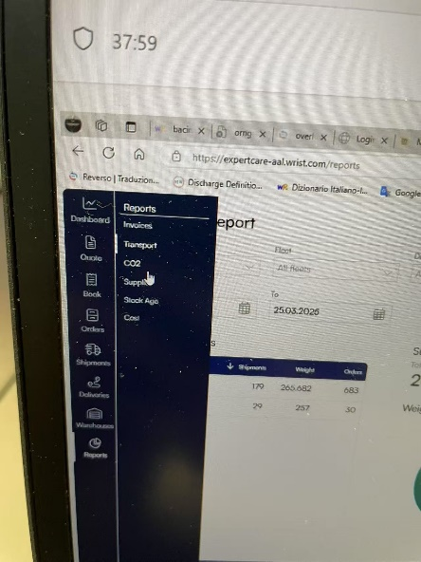

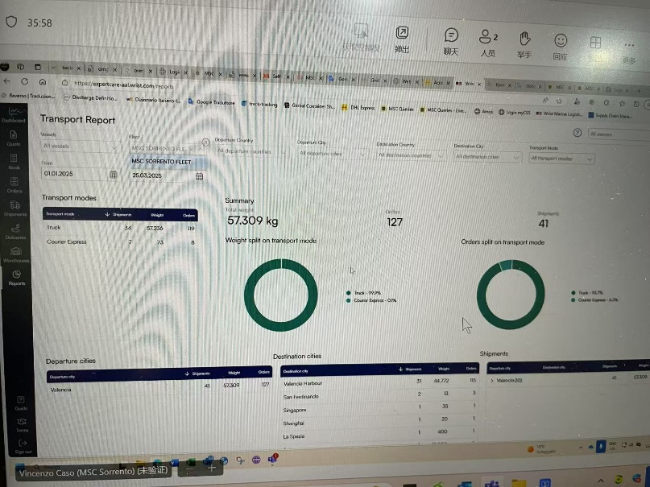 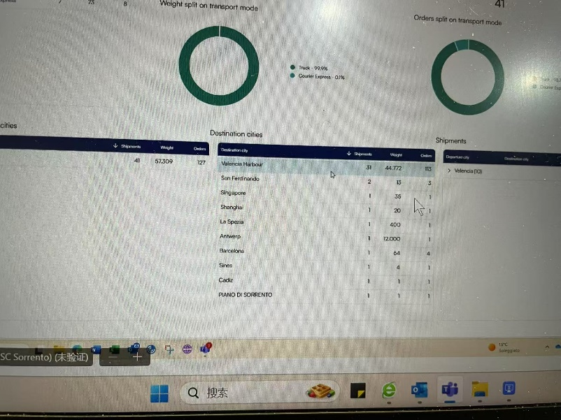

**2. Inventory Management**

* **Stock Overview**:
  + Stock age analysis (current stock vs. aging thresholds).
  + Stock location tracking (warehouse, vessel, or in-transit).
* **Filters**:
  + By vessel/fleet, owner reference, location (origin/current), or stock status.

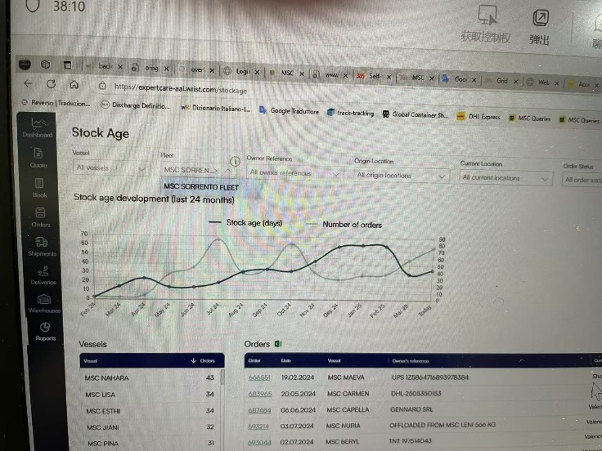 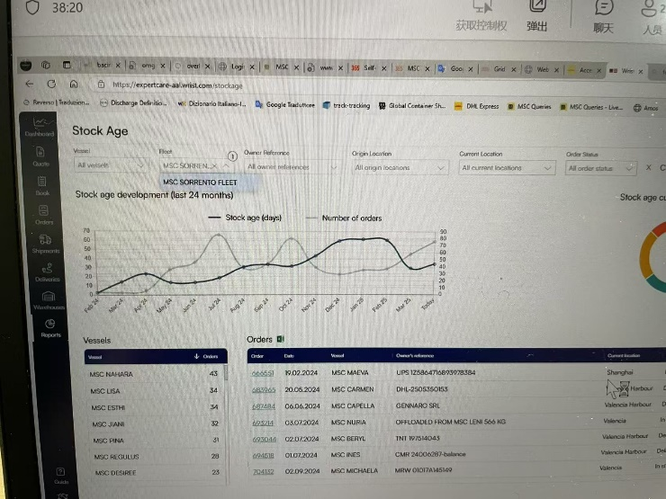

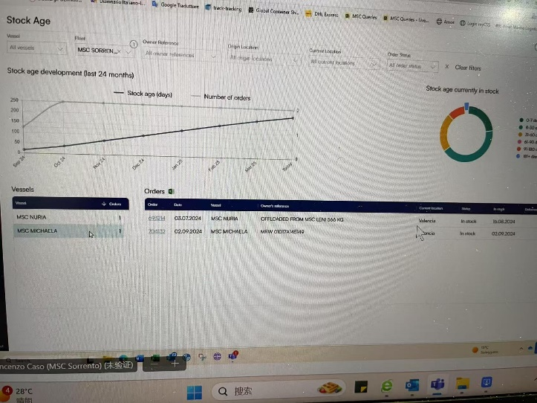

**3. Orders & Shipments （existing）**

* **Shipment Tracking**:
  + Real-time shipment updates (location, ETA).
  + Transport mode details (sea freight: LCL/FCL, air freight, courier).
  + Document access (BOL, customs clearance, invoices).
* **Filters**:
  + By transport mode, departure/destination city, order status.

**4. Supplier Management**

* **Supplier Dashboard**:
* Suppliers – number of order by supplier
  + Supplier
  + Orders
  + Weight (KG)
  + Average (KG)
  + Numbers of order – activity compared to previous 12 months
    - Past 12 months
    - Previous 12 months
  + Hub Transport – Share of Orders
  + Order Origin – number of orders by country (top 20)
* **Filters**:
  + Suppliers

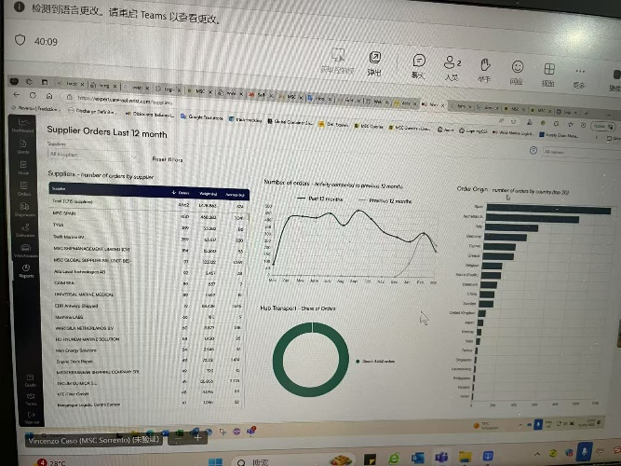

**5. Cost & Analytics**

* + - Cost Analysis
      * Vessel
      * Fleet
      * Transport Mode
      * Departure Country
      * Departure City
      * Destination City
      * Cost Group
      * Cost Type
      * From
      * To
    - Cost per Transport Mode
      * Transport Mode
      * Cost per KG
      * Cost per Order
    - Cost Group
      * Cost Group
      * Cost per KG
      * Cost
    - Cost Distribution
      * Freight Rates
      * Origin Charges
      * Destination Charges
      * Import Charges
      * Other Charges

